- Web: https://festo.com/
Actuators and drives > Pneumatic cylinders > Piston rod cylinders > Round cylinders > Round cylinder DSNU-S (Level cần lấy) > Round cylinder DSNU-12-70- P -A (Sản phẩm cụ thể, kp dòng/series)
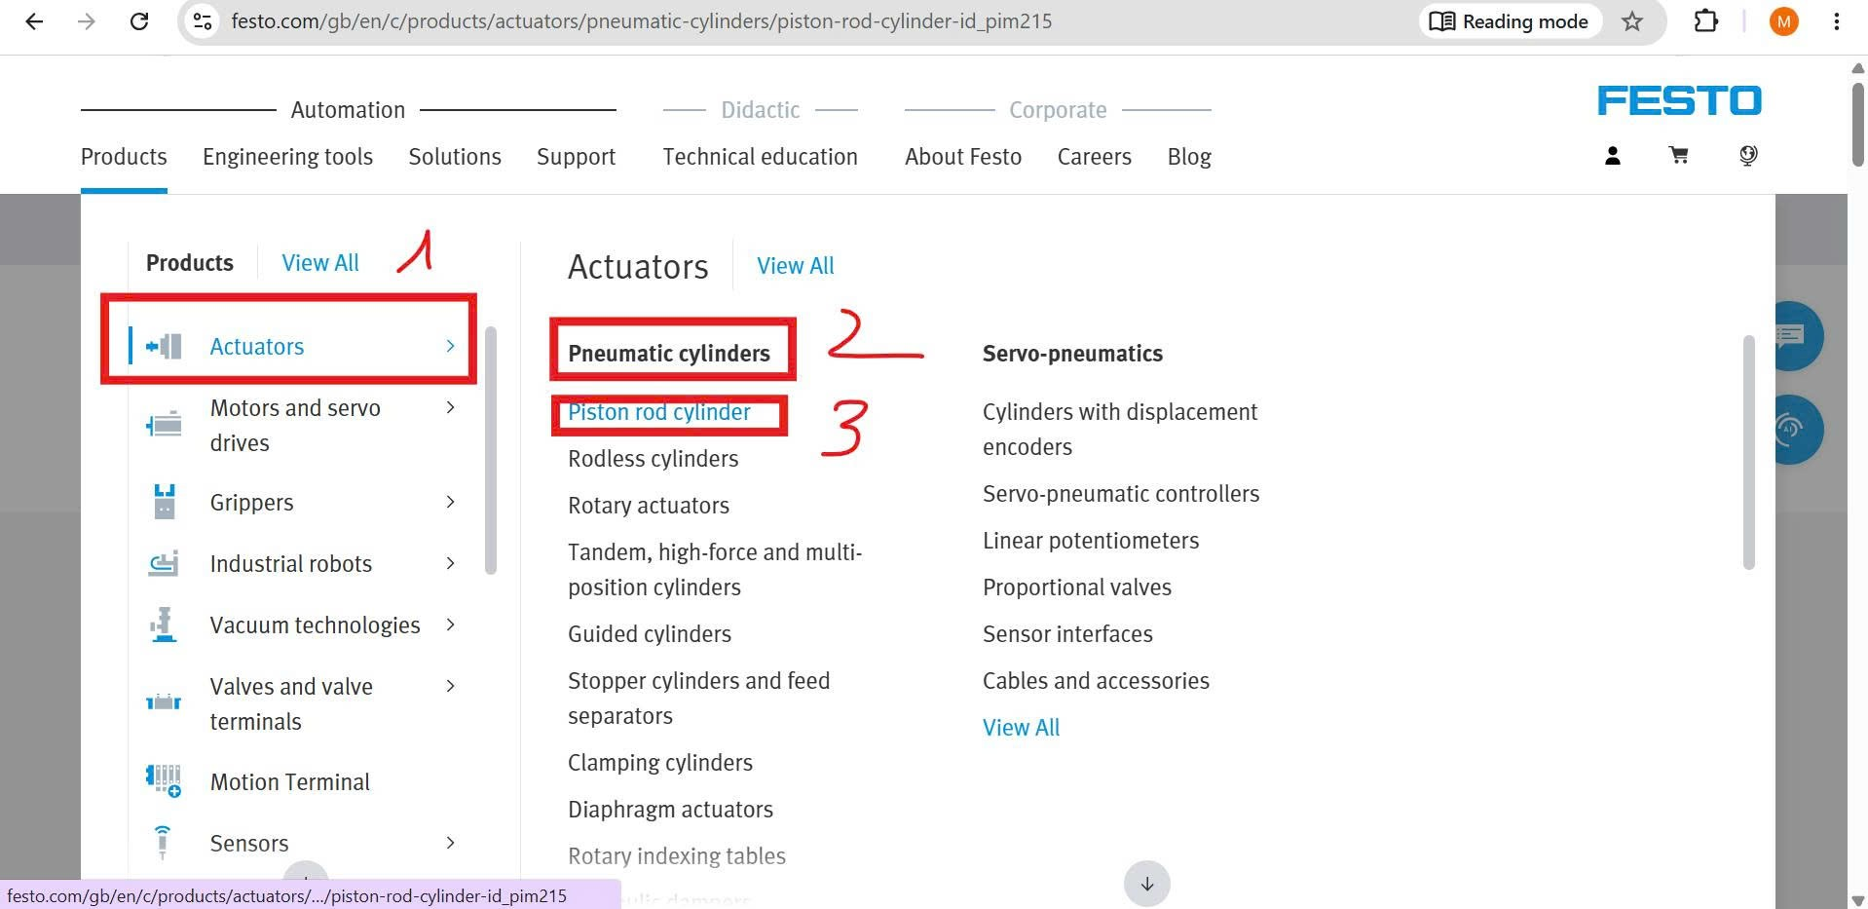
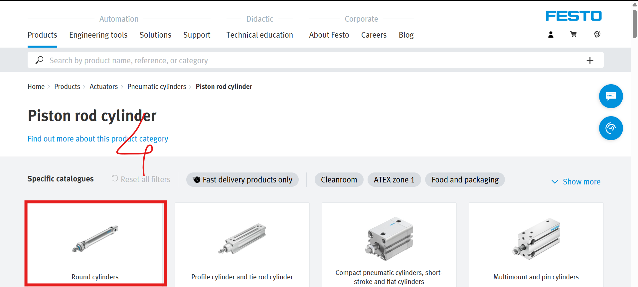
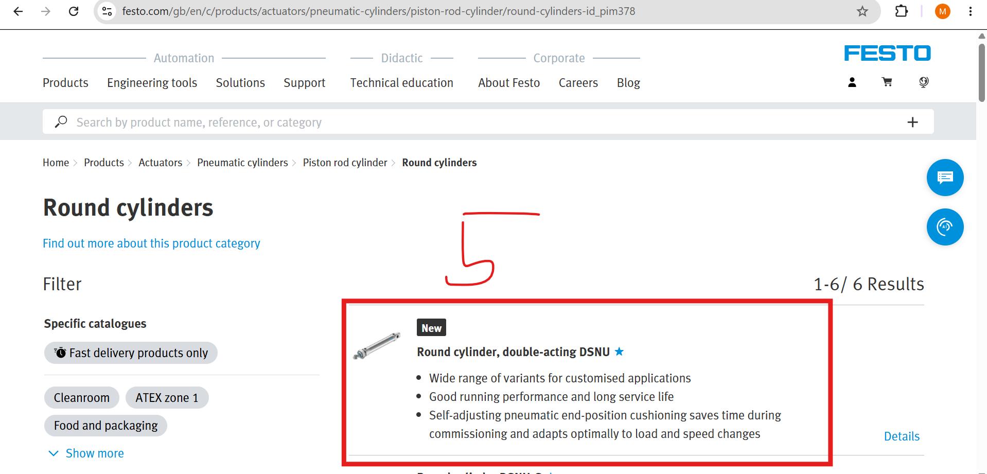
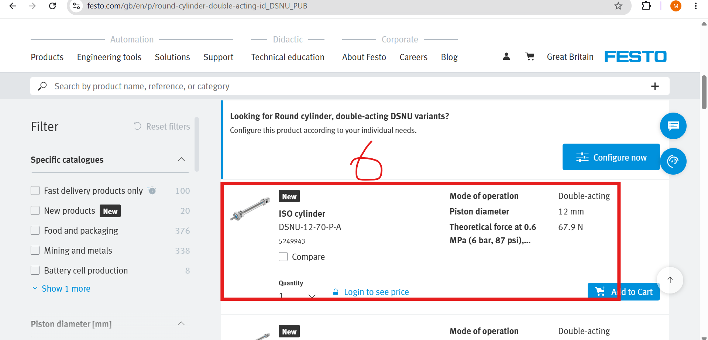

- Web: https://www.wenglor.com/en/
Sensors > Optoelectronic sensors > Laser sensors for distance measurement > Triangulated laser >

P1PC Series: Versatile sensors for all challenges (Level cần lấy) > P1PC011

P3 Series: Laser precision with an intelligent usage concept (Level cần lấy)> P3PC002

PNBC Series: Real-time measurement with micrometer-level accuracy(Level cần lấy) > PNBC101


